**Mobile Robotics 2016**

Tried by Yuwei Chen

Q1:



The **Three Laws of Robotics** (often shortened to **The Three Laws** or known as **Asimov's Laws**):

**First Law**

A robot may not injure a human being or, through inaction, allow a human being to come to harm.

**Second Law**

A robot must obey the orders given it by human beings except where such orders would conflict with the First Law.

**Third Law**

A robot must protect its own existence as long as such protection does not conflict with the First or Second Laws.

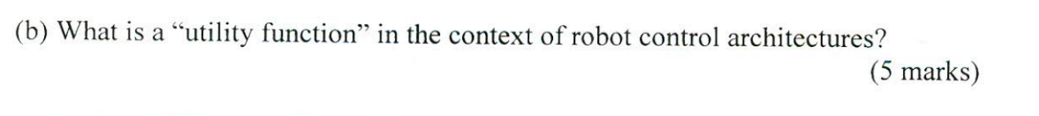

Intelligent agent. (NOT SURE)

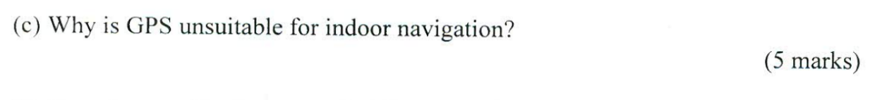

Because microwaves will be attenuated and scattered by roofs, walls and other objects.

Will add the difficulties to control robot.

And will reduce the accuracy of control.

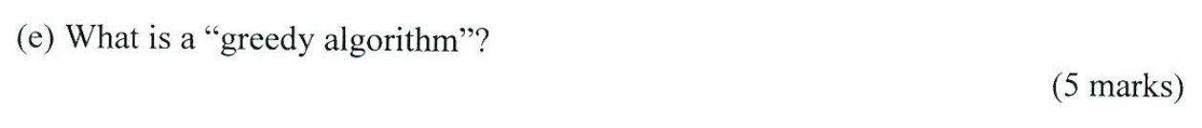

A **greedy algorithm** is an [algorithmic paradigm](https://en.wikipedia.org/wiki/Algorithmic_paradigm) that follows the [problem solving](https://en.wikipedia.org/wiki/Problem_solving) [heuristic](https://en.wikipedia.org/wiki/Heuristic_(computer_science)) of making the locally optimal choice at each stage[[1]](https://en.wikipedia.org/wiki/Greedy_algorithm#cite_note-NISTg-1) with the intent of finding a [global optimum](https://en.wikipedia.org/wiki/Global_optimum).

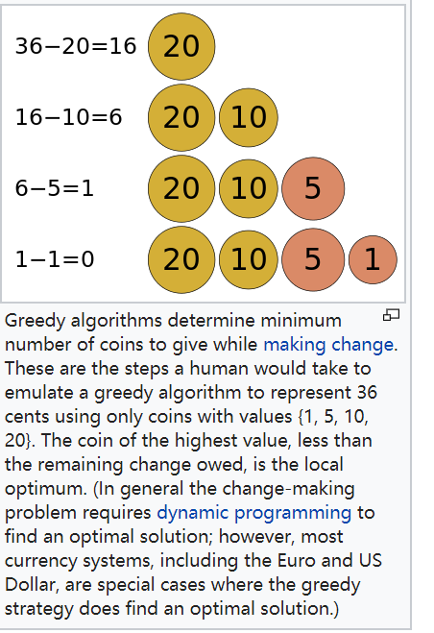



Some of the advantages of servo motors over stepper motors are as follows:

* High intermittent torque
* High torque to inertia ratio
* High speeds
* Work well for velocity control
* Available in all sizes
* Quiet

Some of the advantages of stepper motors over servo motors are as follows:

* Low cost
* Can work in an open loop (no feedback required)
* Excellent holding torque (eliminated brakes/clutches)
* Excellent torque at low speeds
* Low maintenance (brushless)
* Very rugged - any environment
* Excellent for precise positioning control
* No tuning required



What do you understand by the terms ”stochastic environment”?

Situations or models containing a random element, hence unpredictable and without a stable pattern or order. All natural events are **stochastic** phenomenon. And businesses and open economies are **stochastic** systems because their internal **environments** are affected by random events in the external **environment**.

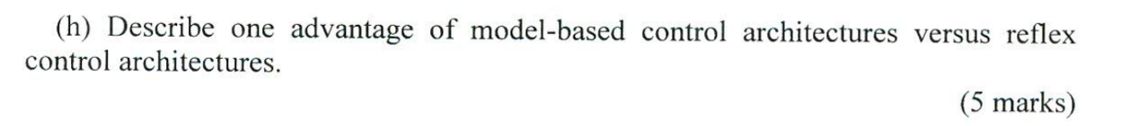

Describe one advantage of model-based control architectures versus reflex control architectures.

Q2:

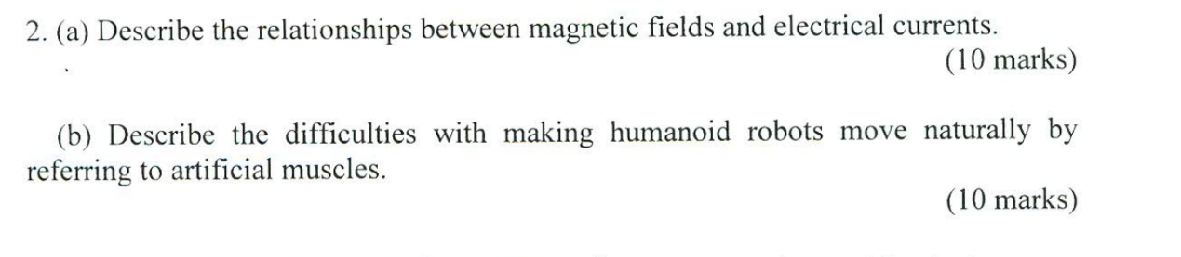

A: Describe the relationship between magnetic fields(磁场) and electrical currents（电场）.

a changing magnetic field produces an electric current in a wire or conductor. The relationship between electricity and magnetism is called electromagnetism.

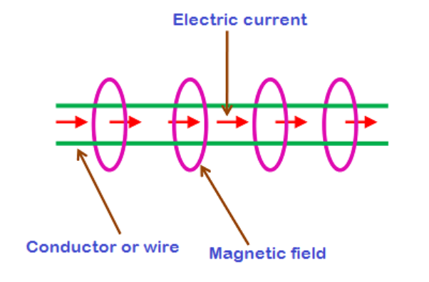

B: Describe the difficulties with making humanoid robots move naturally by referring to artificial muscles（人造肌肉）.

For humans, it comes perfectly naturally. But walking on two legs is actually a complicated task, requiring several muscles to perform delicate balancing acts. That's why, in spite of years of major technological advancements in the field, [humanoid](https://phys.org/tags/humanoid/)robots are still far from being able to get around easily and reliably.

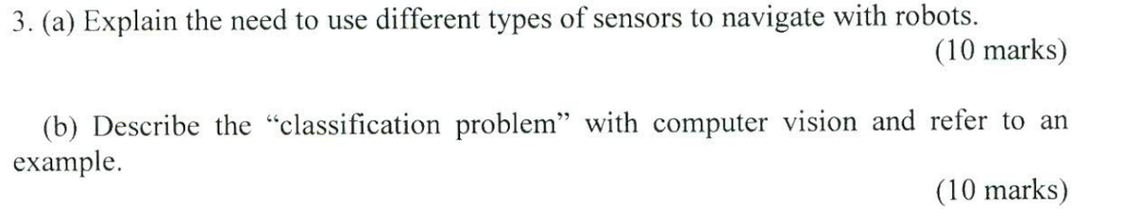

a: Explain the need to use different types of sensors to navigate with robots.

First of all, different types of sensors allow the **robot** to become more autonomous because it can perceive its own environment and through programming it can make decisions based on what it perceives. When navigate a robots, robot cant get to the destination only by use GPS, need use different types of sensors to collect data to control robot’s move, like make a turn, go forward go back and the speed of robot, Avoid obstacles, ect.

B: Describe the “classification problem” with computer vision and refer to an example.

A classification problem is when the output variable is a category, such as “red” or “blue” or “disease” and “no disease”. A classification model attempts to draw some conclusion from observed values. Given one or more inputs a classification model will try to predict the value of one or more outcomes.  
For example, when filtering emails “spam” or “not spam”, when looking at transaction data, “fraudulent”, or “authorized”. In short Classification either predicts categorical class labels or classifies data (construct a model) based on the training set and the values (class labels) in classifying attributes and uses it in classifying new data. There are a number of classification models. Classification models include logistic regression, decision tree, random forest, gradient-boosted tree, multilayer perceptron, one-vs-rest, and Naive Bayes.

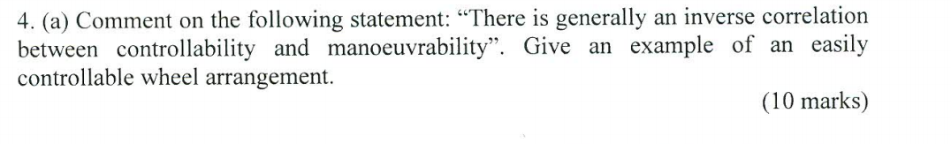

A: Comment on the following statement:”There is generally an inverse correlation between controllability and manoeuvrability”. Give the example of an easily controllable wheel arrangement.

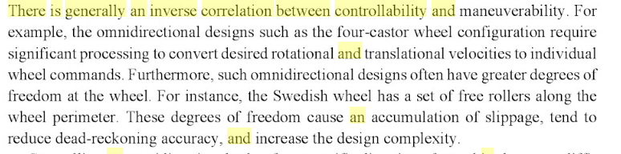

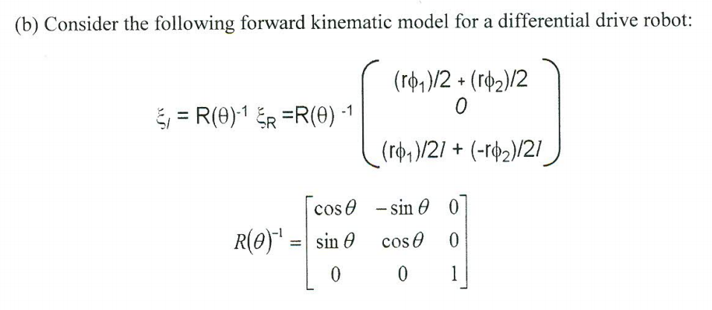

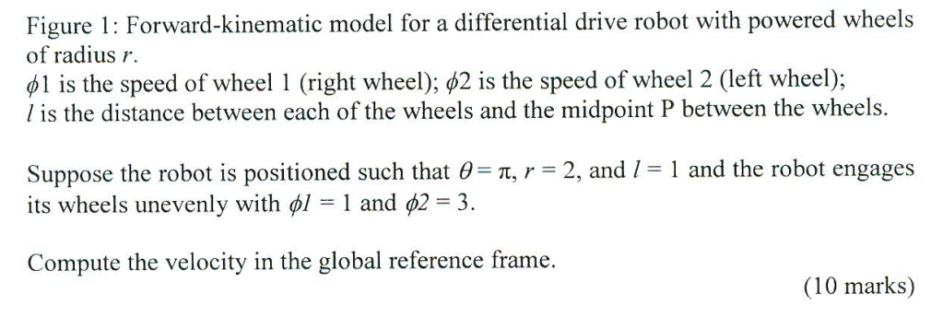

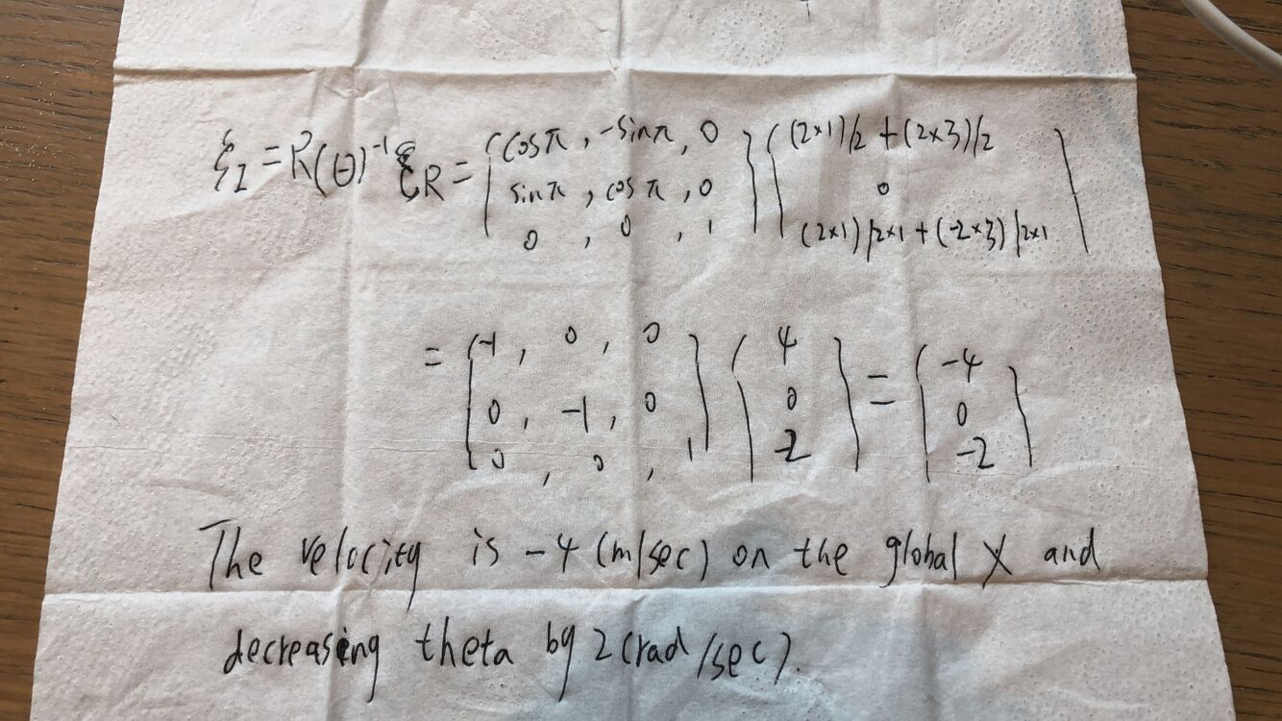

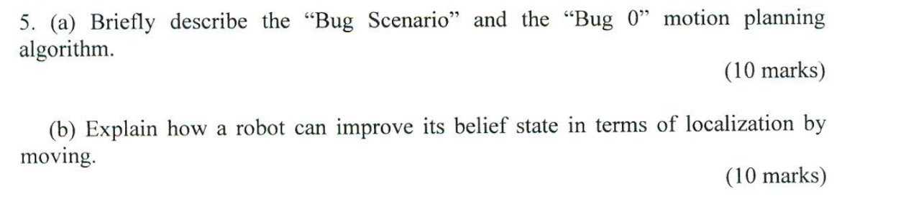

A:Briefly describe the”Bug Scenario” and the “Bug 0” motion planing algorithm.

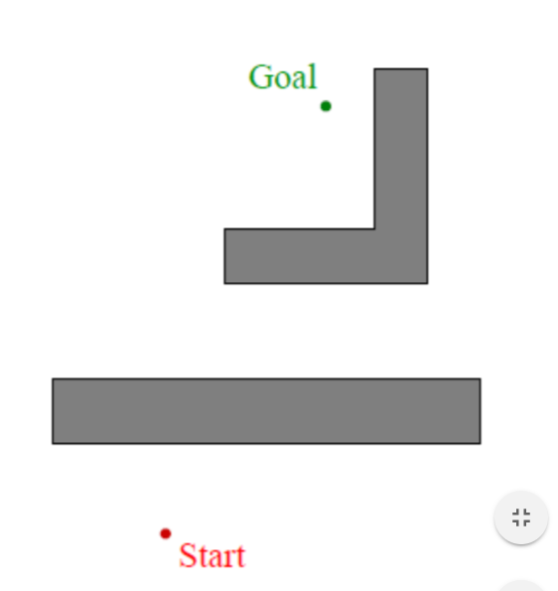

Robot wants to get from start to goal It knows the location of the goal relative to its own internal reference frame It does not have a global map of the environment Assume essentially tactile sensing

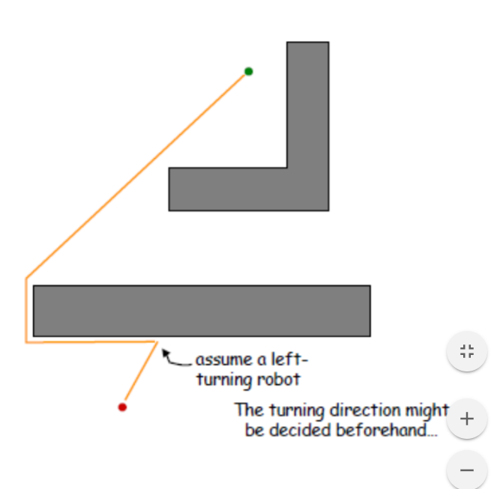

“Bug 0” algorithm

1. head towards goal
2. if contact is made with an obstacle then follow the obstacle’s boundary (toward the left) until heading toward the goal is possible again
3. continue heading towards goal

B: Explain how a robot can improve its belief state in terms of localization by moving.

Use “Bug 2” algorithm to get to direction during robot moving.

We know the line between the starting point and the end point in an environment with no obstacles . We call this the m -line .

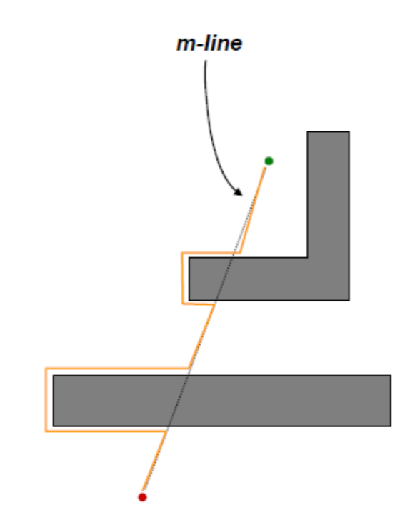

“Bug 2” algorithm

1. head toward goal on the m -line
2. if an obstacle is in the way, follow it until encountering the m - line again closer to the goal.
3. Leave the obstacle and continue toward the goal

Bug 2 is a greedy algorithm

Bug 2 is generally faster at finding a solution